Name

Student number

Examination for DDBI 2016 – March 24th 2016

Read the instructions below carefully

The exam paper (this document) which contains the questions. There are 5 parts in the exam, corresponding (to some extent) to the 5 parts of the book of Crawford and Di Benedetto. Each part has several questions which are in total worth 20 points. Therefore, this exam is graded with maximal 100 points in all.

Space for answers is provides below the questions.

Write down your name and student number on top of this page

Remember:
  - Answers must be in English.
  - Please write legibly so that we can read/understand your answers.
  - Write down any assumptions that you made and you feel are important. But please note that these assumption should be sensible, and do not exaggerate (“over-use”) them.
  - In case of any doubts, please ask the invigilator.

Part 1.

Question 1.1 (5 points):

What are the three top reasons why new products sometimes fail in the market?

Answer:

- No need for the product [p. 16] [repeated in ch 5 p 131]
- There is a need, but the product does not fulfil the need (in other words, it was not unique and superior. (HW: this is not the same in other words, but a further specification) - not required)
- It was not properly communicated [p 193]

Question 1.2 (5 points):

Consider the PIC for a new pencil:

“Against the background of increasing digitization, the demand for pencils for writing on paper is steadily decreasing. However, demand for pencils on hand held devices is increasing. There is no pencil on the market which can do both.
Using the Company’s patented ink-on-demand technology, a pencil should be developed which automatically yields ink when writing on paper and does not spread ink when writing on anything else (in particular, when writing on screens).
As guidelines, the team should follow the Company’s protocol for innovation, and adhere to the Company’s general ethics and sustainability policy. The financial investment should satisfy Company’s rules on ROI.”

Which topics are missing in the above PIC?

Answer:

- Market focus (market dimension) is missing
- Goals and objectives are missing
- Evaluation measurements are missing

Question 1.3 (4 points):

In the syllabus on the data-driven part of the course, several chapters from the book by Powell and Baker are reproduced. In section 2.3 of this book, the notion of influence charts is introduced, as preparation for building spreadsheet models. In the toll-gate 1 assignment, some students start with the following figure to attain a full influence chart.

Launch
Market
test
Prepare
Techni.Aspects
For launch
Prepare marketing/sales
For launch
Supply &
Production
Scale Up
Complete marketing & launch plan
Development
Docs

There are many reasons why the above picture is not a correct influence chart. Please provide at least two (different) reasons.

Answer:

- The symbols do not contain variables which may be given values
- The arrows do not represent influencing relations (as in functions of formula’s) but precedence relations
- There is no difference in meaning between different symbols

Questions 1.4 and 1.5

For the tollgate 2 assignment, student teams have to make a business case for the concept chosen. In particular, they have to show a proper return on investment (ROI) to the managers or investors who are to provide the money.

Some students propose to use the Dupont analysis for creating this business case. According to Wikipedia, “The Du Pont identity breaks down Return on Equity (that is, the returns that investors receive from the firm) into three distinct elements. This analysis enables the analyst to understand the source of superior (or inferior) return by comparison with companies in similar industries (or between industries)”. A well-known scheme for the DuPont analysis is given below.

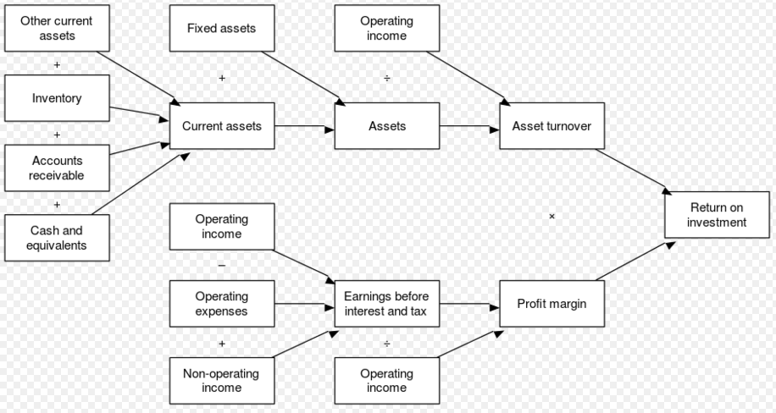

Question 1.4 (3 points):
Can the above DuPont scheme be transformed into an influence chart for preparing a spreadsheet model? How? please provide a short argument for your answers
Answer:
Of course. It is nearly an influence chart, if boxes are replaced by ellipses, except for the last symbol (hexagon) and for some symbols that could represent fixed values (triangles), such as fixed assets.

Question 1.5 (3 points):
Is the DuPoint analysis suitable for a ROI calculation for tollgate 2?
Answer:
No. This analysis is mentioned to benchmark firms and not innovation projects. This is obvious form the Wikipedia text, but also because the variables used are not linked to innovation-related variables.

Part 2.

Question 2.1 (3 points):

A product is characterized as a number of attributes. These attributes are categorized as Features, Functions, and Benefits in a so-called typology.

Please provide two examples of each attribute for a spoon in the table below.

Answer:

Feature | Function | Benefit
Bowl | Holder of liquids | Neatness of consuming fluid materials
Handle | Carrier of liquids | Table orderliness

Question 2.2. (2 point):

In a determinant gap map, attributes of products are used to position products in relation to each other. The determinant attributes should obviously be important, but they should also have another property.

Which other property should determinant attributes have?

Answer:

These attributes should be differentiating (or discriminating) between products.

Question 2.3 (5 points):

Perceptual maps may also be based on attribute ratings by e.g. customers. This leads to large data cubes of customer perceptions of particular attribute values for existing products. In order to reduce complexity, a statistical technique called factor analysis is described in the book of Crawford and Di Benedetto.

Let us assume that the innovation project for a new hammer is performing a perceptual gap mapping based on 20 attribute ratings by 100 potential customers for 10 existing hammers. This results in a data cube of 20.000 data points of ratings per respondent per attribute of existing products. Assume that a factor analysis is performed. When only two factors are used, about 65 % of variance is explained, but if three factors are used, about 90% of variance is explained.

The team chooses to take three factors as determinants for customer preferences, which are labelled as:
- Weight of the hammer
- Balance of the hammer
- Aesthetics of the hammer.

The team wants to perform a gap analysis based on these three factors as dimensions. The development manager prefers a gap analysis based on two dimensions, arguing that there is probably a high correlation between Balance and Aesthetics, so that these two dimensions may be merged. The manager calls for a correlation analysis of the factor Balance and the factor Aesthetics, in order to see if the correlation is high enough for merger of these factors.

What are the possible outcomes of such a correlation analysis?

Answer:

The only possible outcome is that the correlation is not high enough for merger. The factor analysis with two factors already showed disappointing results.

We came to realize that the interrogative sentence "What are the possible outcomes of such a correlation analysis?" can be confused with "How the management should react to the outcome of such a correlation analysis?". Thus, we also consider the following as a correct answer: If the analysis shows that the correlation is not high enough, then factors should not be merged, and they can be merged otherwise.

Questions 2.4 and 2.5

In Chapter 7 of Crawford and Di Benedetto, the conjoint analysis method is introduced. The method is based on comparison of feature values by potential customers, e.g. by using cards which are ordered according to the respondent’s preference. The method determines the utility assigned by these respondents to different values of product features.

Question 2.4 (4 points) :

In the second lecture on data analysis, a distinction was made between data measured on a nominal scale, on an ordinal scale, on an interval scale and on a metric scale. Which scale is used in a conjoint analysis?

Answer:

Ordinal data

Question 2.5 (6 points):

A first step in conjoint analysis is often, to make descriptive statistics of utility preferences of several users, stratified according to different target groups. These descriptive statistics show in the first place the centrality and the spread of the utility values.

For centrality, we have two measures discussed in the lecture:
- The mean
- The median

For spread, we can also use two measures:
- The variance
- The percentiles (25% and 75%)

Which methods would you prefer for centrality and spread and why?

Answer:

Median and percentiles. For ordinal data, mean and variance are meaningless.

Part 3.

Questions 3.1 and 3.2

In the table below, the matrix of Risk/Payoff is displayed, which is identical to figure 8.3 in the book of Crawford and Di Benedetto. The book argues, that error AB is much worse than error BA.

If the  product  were marketed  Decision is to: | A  Stop the project now | B  Continue to next evaluation
A. It would fail | AA (no error) | BA (go error)
B. It would succeed | AB (drop error) | BB (no error)

Question 3.1 (2 point):

What is the reason for arguing that that error AB is much worse than error BA?

Answer:

Throwing out a winner is much more costly than all development costs concerned.

Question 3.2 (4 points):

However, there is a counter argument against the argument given in question 3.1.
- What is the counter argument
- When does it apply?

Answer:

- The counter argument is, that the money spent on the particular product could have been better assigned to another product with better chances.
- It applies if there are many other good candidates waiting to be screened.

Questions 3.3 to 3.5

The following questions are concerned with various models to forecast (in the product evaluation phase of NPD) new product sales over the life cycle. We will first compare the Bass model with the ATAR model and thereafter investigate the role of the Holt Winters method.

For your convenience, we provide the Bass model formulas now:

Bass Diffusion model:

p initial trial probability
q diffusion parameter
m number of potential buyers

s(t) = pm + (q-p)Y(t) – (q/m)((Y(t))²

where

s(t) = sales at time t
Y(t) = sales before time t.

Question 3.3 (3 point):

Which factor is modelled explicitly in Bass, but not in ATAR?

Answer:

Diffusion rate and time (one of these is enough)

Question 3.4 (4 point):

Which factors are modelled explicitly in ATAR and not in Bass?

Answer:

Awareness, Availability and Repeat buy are modelled in ATAR but not modelled in Bass

Question 3.5 (4 point):

The Holt Winters model for forecasting cyclic patters is as follows:

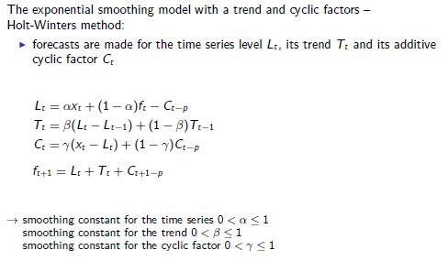

Is it possible to use this model not so much to predict a seasonal pattern but as alternative for Bass to estimate the sales over the life cycle? Please provide arguments

Answer:

No, this is not possible, because the Holt Winters model is based on several cycles to estimate the effect of a new cycle. There is only one (half of a) ‘cycle’ in this case.

Question 3.6 (3 points):

Below, you will find a stripped reproduction of Figure 11.6 of Crawford and Di Bendedatto. Please put the right circles with letter for various testing methods in the right place in the figure.

NPD process ------------------------------------------
Opportunity
identification
and selection
C
Concept test
F
Full screen
Market test
Product use test
M
P

Development
Launch
Rest of
market life
Project
evaluation
Concept
generation
Technical Marketing

Answer:

M:Development/Marketing, C:Project Evaluation, P:Development/Technical, F:Project Evaluation

Part 4.

Questions 4.1 and 4.2

These questions are concerned with Universal design.

Question 4.1 (2 point):

What means universal design?

Answer:

The design of products which can be used regardless of age or ability

Question 4.2 (4 points):

Mention two principles of universal design, with a short explanation.

Answer:

See Figure 13.2, page 329

- Equitable Use: The design is useful to people with varied abilities.
- Flexibility in Use: The design accommodates a variety of preferences and abilities.
- Simple and Intuitive to Use: The design is easy for anyone to understand and use.
- Perceptible Information: The design communicates the required information effectively to the user.
- Tolerance for Error: The design minimizes adverse consequences of inappropriate use.
- Low Physical Effort: The design can be used effectively by anyone with minimal fatigue.
- Size and Space for Approach and Use: Regardless of the user’s size or mobility, the product is easy to reach, manipulate and use.

Questions 4.3 to 4.5

These questions concern DFM, DFA and virtual reality

Question 4.3 (2 point):

What means DFM? Please provide a short explanation

Answer:

Design for manufacturability: to ensure that a design can be manufactured.

Question 4.4 (4 points):

What means DFA? Please provide a short explanation. What is the relation with DFM?

Answer:

Design for assembly: to ensure that a design can be assembled (manually and/or with robotics). DFA is a sub discipline of DFM

Question 4.5 (2 points):

How can virtual reality in combination with CAD contribute to DFA?

Answer:

Engineers can simulate in virtual reality how assembly takes place, by have a 3D CAD model of the product and the workplace imported in a virtual realty world and inspect the logic and ergonomics of the assembly process.

Questions 4.6 and 4.7

These questions concern product use testing.

Question 4.6 (3 points):

What are the two main arguments usually to skip product use testing?

Answer:

- We have working on this concept for many months – we know already what we need to know
- We will lose valuable time before launch (and the competition is ahead of us) as well as resources that we need for further development and marketing efforts

Question 4.7 (3 points):

What are the two main counter arguments, enforcing product use testing?

Answer:

- There is still no evidence that our product really solves a customer need satisfactorily
- The risks and costs of product use tests are small as compared to the risk of troubles which have to be fixed later

Part 5

Question 5.1 (2 point):
The Launch phase consists of two parallel, synchronized streams of work. Which are these?

Answer:

Technical launch and Marketing launch (see p. 402).

Question 5.2 to 5.5

These questions pertain to testing activities in relation to other activities during the launch phase. Two activities (out of many activities) in the launch phase are:
- Build regular production capability
- Production scale up

The last question ask, if testing should proceed before or after the two activities mentioned.

Question 5.2 (2 points):

What is alpha testing?

Answer:

Alpha testing is product use testing with own personnel.

Question 5.3 (2 points):

What is beta testing?

Answer:

Beta testing is short-term product use testing at customers.

Question 5.4 (2 points):

What is Gamma testing?

Answer:

Gamma testing is product use testing with real customers.

Question 5.5 (3 points):

Should beta and gamma testing be performed before or after
- Build regular production capability
- Production scale up?

Why?

Answer:

It should be done with the real product that the company intends to bring to the market. Therefore, it is preferably after build regular production capability It should preferably be done before production scale up (in order to allow taking advantage of the results; however, sometimes this is not possible because of the number of products needed – not supposed to be in the student’s answer)

Questions 5.6 to 5.7

These questions are related to patters that may be observed after launch of a pharmaceutical product, which does not require medical prescription. Below, two such products are shown which are 10 weeks on the market. In each case, the firm had to decide whether there was a problem, what the problem was (if any) and what to do about it. In each case, the awareness in the market after 10 weeks was planned to be 60%, the trial rate was planned to be 50% (i.e. of 60%, so 30% of target market) and reuse level was planned at 40% (i.e. of 30%, so 12% of target market). The goods supply chain was ramped up accordingly.

Question 5.6 (3 points):

Consider the numbers in the figure below. What is the problem in this case and what could be done to repair it?
Aware
Unaware
70%
30%
Not tried
Tried
16%
54%
8%
Repeat buy
No Repeat buy
8%

Answer:

The problem is disappointing sales (8% of target as opposed to 12%). The problem is obviously not caused by awareness (which is higher than planned) but in the trial rate. One option mentioned in the book (p.496) is to put a heavy samples-mailing program in action. But any option that make the product more accessible for trial should do.

Question 5.7 (3 points):

Consider the numbers in the figure below. Presumable, the problem is that customers are not aware of the product. Therefore an enhanced awareness program seems obvious. Would you support this claim and reasoning? Explain why.

Aware
Unaware
40%
60%
Not tried
Tried
24%
16%
12%
Repeat buy
No Repeat buy
12%

Answer:

There is no problem here in sales, because sales is as planned. There may be a problem in awareness, but the company should NOT raise an enhanced awareness program immediately, because they cannot supply enough. The situation can be seen as an opportunity in the market, where first supply should be ramped up and thereafter an awareness enhancement program can be started.

Question 5.8 (3 points):

In chapter 20 of the book of Crawford and Di Benedetto, public policy issues are discussed. They present a life cycle of public policy issues in figure 20.1, which is reprinted below.

State of
idleness
Diffused
by
those
attacked
I.stirring
II.……..
III. Political arena
IV.Regulatory
Adjustment

What is in the second box? Provide a short explanation

Answer:

See p 517.

Trial support: This is where a political base has to be established for the cause.

