31-1-2017 | Strategic Management of Information Technology | Elective of TOM and SCM
This is a very short summary of the articles of Strategic Management of Information Technologies. It takes the essential of all articles and is intended to be supplementary to reading the articles. Hopefully it enables you to put the articles in context of each other. Without prior deeper understanding of the articles this document probably means nothing to you

Lecture 1

Carr (2003)
Information Technology (IT) is a commodity; therefore no competitive advantage is gained.
IT management should:
- Spend less
- Follow, don’t lead
- Focus on vulnerabilities, not opportunities

Wade (2015)
Digital transformation

Digital business
agility
Play chords not keys

Lecture 2

Porter (1996)
- Operational effectiveness is not a strategy
- Strategy rests on unique activities
- A sustainable strategic position requires trade-offs
- Fit drives both competitive advantage and sustainability
- Rediscovering strategy

Chen et al. (2010)
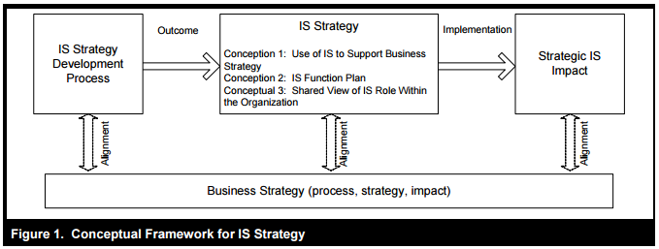

Matt et al. (2015)
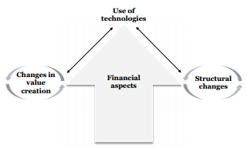
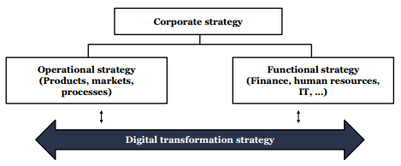

Lecture 3

Luftman & Kampaiah (2007)
Maturity of IT business criteria:
- Communications
- Value
- Governance
- Partnership
- Scope and architecture
- Skills
Business can fall in 5 different levels of maturity based on the criteria above.

Mueller (2010)
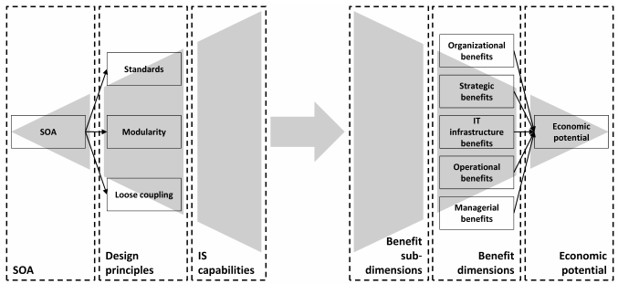

Weill & Ross (2005)
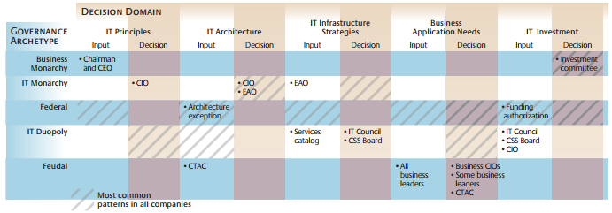

Lecture 4

Bharadja (2000)
RBV extension
+++
IT capabilities Firm performance (based on empirical evidence)

Aral & Weill (2007)
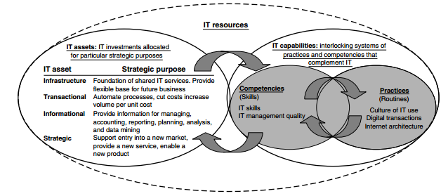

Nevo & Wade (2011)
Firm performance by IT when (based on empirical evidence):
- IT asset combined with an organizational resource
- Outside-in IT enable resources

Lecture 5

Pavlou & El Sawy
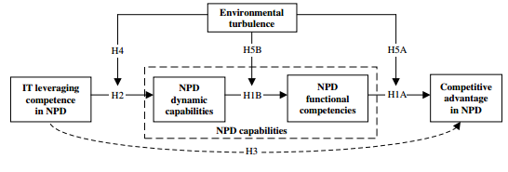

Dong & Yang (2015)
Company absorptive capacity
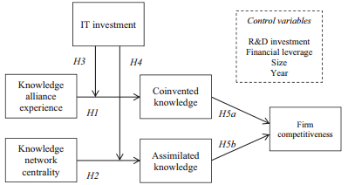

Dong & Wu (2015)
Online user innovation communities have:
- Potential for increased firm performance when there is idea generation
- But only give actual firm performance if it also includes idea implementation

Lecture 6

Ray et al. (2013)
IT Capital
Assets
Firm scope
-Vertical integration
-Diversification

Tippins & Sohi (2003)
IT Competency > Organizational Learning > Firm Performance
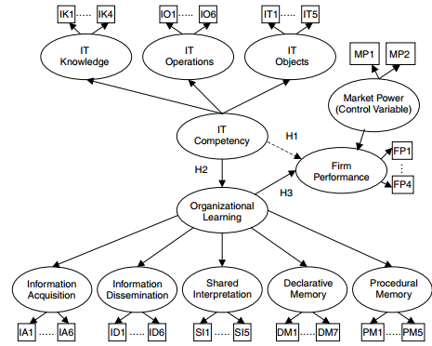

Ho et al. (2011)
Empirical evidence from emerging markets show board independency and foreign shareholders have a positive moderating effect on the IT investments/firm performance relation
Corporate governance
IT investments
Firm performance

